
DEAL CHAMBER & OF WALMER TRADE LTD

Stranger in the Window Competition Entry £1
19th July – 12th August 2024

1st Prize £70 2nd Prize £25 3rd Prize £15

Winners will be notified and names published in East Mercury and our website

Business Name | Address | Stranger
Campbells of Deal Ltd | Units 1-3 Deal Business Park , Southwall Road, Deal | Tennis Ball
Castle Removals | Deal Business Park , Southwall Road, Deal CT14 | Teddy Bear
John Corley Glass Studio | 57 West Street, Deal CT14 6EB | Paddington Bear
Linden Hall Studios | 32 St Georges Road, Deal Kent CT14 6BA | Pirate Doll
Rees & Rees | 148 High Street, Deal, Kent CT14 6BE | Small Plastic Dinosaur
Beautiful Homes | 140 High St, Deal CT14 6BE | Wooden Toaster Tong
Joanne Harmer | 134 High St, Deal CT14 6BE | Seashell
Tower Design and Print Ltd | Landmark Centre, 129 High St, Deal CT14 6BB Car Park at back via Union Road | Pirate Flag
The Deal Pirates Window Display | Entrance Of The Landmark Centre 129 High St Deal | Yellow Wrist Band
Jenkins & Son | 77 - 81 High Street, Deal, Kent CT14 6BB | Mouse
Taylor Jones & Son | 114 High St, Deal CT14 6BB | Yellow Sort Toy
Merrygardens | 96 High Street , Deal CT14 6EE | Pot of Pink Stuff
The Black Pig | 1 St George's Passage, Deal CT14 6TA | Severed Hand
Brooklyn Greenspa Ltd | 6 St Georges Passage, Deal, Kent | Bust of Horatio Nelson
Dining Club | 69 Middle Street, Deal, CT14 6NP | Penguin & Seal soft toys
Two’s Company | 92 High St, Deal CT14 6EG | Cotton Reel
Gridlock | 89 High Street, Deal CT14 6ED | Poppy
Ward & Corrigan | 73 High St, Deal CT14 6EH | Purple Alien with 5 eyes
Barnardo's | 5-7 King St, Deal CT14 6HU | Coffee Pods
Pier View Amusements | 71 Beach St, Deal CT14 6JA | Boxed Doorbell
Deal Radio | 69a High Street, Deal CT14 6EH | Christmas Tree
Biggs Optician | 68 High St, Deal, Deal CT14 6HE | Paint Brush
Savers | 64 High St, Deal CT14 6HE | Mug
Simmonds | 60 High Street, Deal CT14 6HE | Set of Old Keys
The Deal Bookshop | 52 High St, Deal CT14 6HE | Grey Soft Toy
Arno & Co | 94 High Street, Deal, CT14 6EE | Box of Edible Cubed Ear Wax Treats
Jillys Drycleaners | 5 Broad St, Deal CT14 6ER | Thimble
Appliances For You | 11 Queen St, Deal CT14 6ET | Smart Ass Cards
Bonne Bombe | 8 Queen St, Deal CT14 6ET | Children’s Green Sun Gasses
Farsim Collection Boutique | 33 Beach Street, Deal CT14 6HY | Pink Feather Duster
Deal Beach Parlour | 57 Beach St, Deal CT14 6HY | Yellow Rubber Duck Small
JJ Woods | 11 High Street, Deal CT14 7AA | Hair Band
Kings Coffee Shop | 1 High Street, Deal CT14 7AA | Multi-coloured Lizard
Icy Hog | 2a South Street, Deal Kent | Small Bob Cat Plastic Toy

Correspondence & Registered address: 69a High street, Deal CT14 6EH. Co.Reg. No 463493 Registered in England. Website www.dwchamber.co.uk

DEAL CHAMBER & OF WALMER TRADE LTD

Business Name | Address |  |  | Stranger
Mark 1 Music | 12-16 Victoria Rd, Deal CT14 7BN |  |  | Iron
Bright & Bright | 29 Victoria Road, Deal, Kent CT14 7AS |  |  | Small Cowboy Boot
Bank House Property | 68 The Strand, Walmer, CT14 7DP |  |  | Lego Figure
Bee Crafty Bee Happy | Shop 2, 49 The Strand, Walmer CT14 7DX |  |  | Spiderman Toy
The Pet Food Shop | 49 The Strand, Walmer CT14 7DX |  |  | Box of Teabags
Colebrook Sturrock | 17 The Strand, Deal, Kent CT14 7DY |  |  | Batman Lego Mini Figure
Wale & Sons | 10-11 The Strand, Walmer, Deal CT14 7DY
Walmer Tiles | 1 The Strand, Deal CT14 7DY |  |  | Metal Pencil Sharpener
States of Walmer | 32 Dover Road, Walmer, Kent CT14 7JW |  |  | Painted Rock with Royal Marine on it
Coastal Active | 65 High Street, Deal CT14 |  |  | Knife and Fork
One of the businesses looks like this from the inside.  Where is this? |  |  |  | Answer below please:  ARNO
 |  | 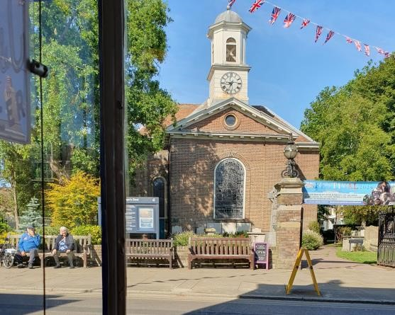

NAME…………………………………………………………………………PHONE……………………….AGE……

ADDRESS…………………………………………………………………………………………………………………

SCHOOL (IF APPLICABLE)……………………………………………………………

All you have to do is find and name the Stranger in the Window at the shops listed on the entry form and complete the following tiebreaker in no more than twelve words, Good Luck !!

I like shopping in Deal because………………………………………………………………………………….

……………………………………………………………………………………………………………………..…..

Please return to: Deal Radio 69a High Street, Deal, CT14 6EH

Closing date: 5.00 pm on Saturday 12th August, visit our website weekly for clues at www.dwchamber/stranger

Please Note: All Information from competitors will only be used for the competition and will be deleted after
Correspondence & Registered address: 69a High street, Deal CT14 6EH. Co.Reg. No 463493 Registered in England. Website www.dwchamber.co.uk

